Bali’s "Silence & Chaos": The Ultimate Nyepi Festival Experience (4N/5D Chennai to Bali Tour)
Experience the "World's Quietest Day" and the "Wildest Night" in one trip!
The Nyepi Festival in Bali is a rare phenomenon where an entire island shuts down for 24 hours of silence. But the night before? It’s a massive street party called the Ogoh-Ogoh Parade. Join Rengha Holidays for an exclusive 4 Night / 5 Day Chennai to Bali Package to witness this "Magic of Contrasts"—from the deafening drums of giant demon statues to the absolute pin-drop silence of a star-filled night.
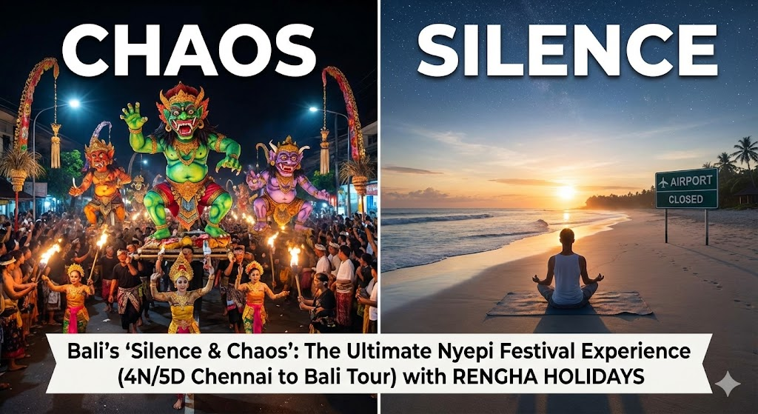

Why This Trip Will Change Your Life (The "Bali Magic")
You have seen beaches. You have seen temples. But have you ever seen an entire country stop?
As we explain to our travelers at Rengha Holidays:
"Oru naal full silence, adutha naal full celebration? Idhu nadakkuradhu Bali la thanga!"
The Contrast:
- The Night Before: Streets full of energy, DJ music, giant "Ogoh-Ogoh" monster statues, and fire dances. Locals and foreigners dance together—language and culture disappear in the fun!
- The Next Morning (Nyepi): Complete Silence. No flights, no traffic, no internet noise. Just you and peace. "Roads empty, airport close
- This is the "Bali Magic": Silence and Celebration on the same island. And Rengha Holidays is taking you there from Chennai!

The Rengha Holidays Exclusive Itinerary: 4N/5D Nyepi Special
Start Point: Chennai International Airport (MAA)
Destination: Bali (Kuta/Ubud)
Theme: Culture, Chaos, and Calm.

Day 1: Arrival & The Calm Before the Storm
- Fly: Depart Chennai (MAA) and land in Bali (DPS).
- Welcome: Meet your Rengha Holidays Guide (who knows the best spots for the upcoming festival).
- Evening: Visit Uluwatu Temple for the sunset. Watch the Kecak Fire Dance—a rhythmic chanting performance that sets the mood for the mythical days ahead.
- Stay: Check into a 4-Star Resort (Important: We pick resorts with great pools/amenities because you will be inside on Day 3!).

Day 2: The "Ogoh-Ogoh" Parade (The Celebration)
- Morning: Relax or shop at Kuta Art Market.
- Afternoon: Walk through the streets to see the giant Ogoh-Ogoh statues (scary, artistic paper-mache monsters) lined up.
- Evening (The Main Event): The Ngrupuk Parade!
  - Witness the locals carrying these heavy monsters, spinning them at intersections to confuse evil spirits.
  - The Vibe: Drums beating, torches burning, and pure electric energy. "Streets full energy & celebration!"
  - Rengha Advantage: We guide you to a safe viewing spot so you can enjoy the chaos without getting lost.

Day 3: Nyepi Day (The Absolute Silence)
- 6:00 AM: The siren sounds. The island shuts down.
- The Experience:
  - Step onto your balcony. Listen. No honking. No planes. Just birds and wind.
  - Use this day for a Digital Detox. Swim in the hotel pool, read a book, or meditate.
  - "Calm venumna Nyepi..." This is your chance to recharge your soul.
- Night: The Star Gazing. With zero light pollution on the island, the Milky Way is often visible to the naked eye. It is a view you will never forget.

Day 4: The "Kissing Festival" & Highland Cool
- Morning: At 6:00 AM, normal life resumes!
- Cultural Twist: Visit Sesetan Village to watch Omed-Omedan (The Kissing Ritual)—a unique ceremony for local youth to wash away bad luck (fun to watch!).
- Drive: Head to Kintamani for a view of Mount Batur Volcano while having lunch.
- Swing: Take the famous "Bali Swing" photo at the Tegalalang Rice Terraces.

Day 5: Souvenirs & Return to Chennai
- Morning: Last-minute shopping for Bali Rattan bags and Coffee.
- Flight: Transfer to the airport.
- Memory: You return home having lived through the loudest and quietest days of your life.

Comparison: Silence vs. Celebration
Why choose one when you can have both?
Feature | Day 2 (Ogoh-Ogoh Parade) | Day 3 (Nyepi Day)
Sound Level | 🔊 100% (Drums, Music, Shouting) | 🔇 0% (Pin-drop Silence)
Activity | Dancing on the streets | Meditation, Pool, Reading
Lighting | Fire Torches & Neon Lights | Pitch Black (Stargazing)
Vibe | "Party Hard" | "Peace Deep"
Traffic | Traffic Jams & Parades | Empty Roads (No Cars Allowed)

Nyepi Survival Guide (Must Read)
- Can I go out on Nyepi Day? No. Tourists must stay inside hotel premises. (That's why Rengha Holidays books luxury resorts with big pools!).
- Is there food? Yes! Hotels operate normally inside. We ensure your package includes all meals for this day.
- Will the internet work? Usually, mobile data is turned off island-wide, but Hotel WiFi stays ON.

Frequently Asked Questions (Q&A)
Q: When is the next Nyepi Festival?
A: Nyepi dates change every year (based on the lunar calendar). Contact Rengha Holidays to check the exact dates for 2026/2027 and book in advance!
Q: Is it safe for families?
A: Absolutely. The parade is loud but friendly. The Silent Day is actually perfect for families to spend quality time together without distractions.
Q: Do we need a Visa?
A: No! Indonesia offers Visa on Arrival for Indians. Just pack your bags and come to Chennai Airport!

🔥 CALL TO ACTION: Experience the "Bali Magic"
Don't be just a tourist. Be a traveler.
Seats for the Nyepi Week sell out 3 months in advance because flights get full.
Book Your 4N/5D Chennai to Bali Package NOW!
📞 Call/WhatsApp: +91 770894141
🌐 Visit: www.renghaholidays.com

